INFORMATION STORAGE AND MANAGEMENT
UNIT I – Introduction to Information Storage and Management
Structured Exam-Ready Notes
SYLLABUS: Storage System Environment, Information Storage, Evolution of Storage Technology and Architecture, Data Center Infrastructure, Key Challenges in Managing Information, Information Lifecycle, Components of Storage System Environment, Disk Drive Components, Disk Drive Performance, Fundamental Laws Governing Disk Performance, Logical Components of the Host, Application Requirements and Disk Performance, Storage Provisioning (including Virtual Provisioning).

HOW TO READ: Content from the PPT is kept in its original wording. Topics that are in the syllabus but missing from the PPT are marked with a red SYLLABUS ADDITION box. Blue = Definition, Green = Formula, Yellow = Key Point, Purple = Mini Summary.

Contents
- Information Storage (Data, Types of Data, Big Data, Information)
- Evolution of Storage Technology and Architecture
- Data Center Infrastructure (Core Elements and Key Requirements)
- Key Challenges in Managing Information
- Information Lifecycle Management (ILM)
- Components of a Storage System Environment (Host, Connectivity, Storage)
- Disk Drive Components
- Disk Drive Performance (Service Time)
- Fundamental Laws Governing Disk Performance
- Storage Design Based on Application Requirements and Disk Performance
- Flash Drives (Solid State Drives)
- Logical Components of the Host
- Concept in Practice: VMware ESXi
- Storage Provisioning (including Virtual Provisioning)
- Quick Revision: Formulas and Important Questions

1. Information Storage
SYLLABUS ADDITION: This topic is part of the syllabus but is not covered in the uploaded PPT. Added in standard textbook form (EMC ISM) so that the syllabus is fully covered.

1.1 Data
DEFINITION: Data is a collection of raw facts from which conclusions may be drawn.

Examples: a handwritten letter, a printed book, a photograph, a movie on video tape, an e-mail, a file on a computer. Data can be generated in digital form (computers, phones, sensors) or non-digital form (paper, film). Today almost all data is handled in digital form, as streams of bits (0s and 1s).

1.2 Types of Data
Type | Description | Examples
Structured data | Organized in rows and columns in a rigidly defined format so that applications can retrieve and process it efficiently. Usually kept in a database. | RDBMS tables, spreadsheets
Unstructured data | Not organized in a way that makes it easy to query or process using a database. About 80 % of organizational data is unstructured. | E-mails, text files, images, videos, web pages, PDFs

1.3 Big Data
DEFINITION: Big Data is a data set whose size or complexity is beyond the capability of commonly used software tools to capture, store, manage and process within acceptable time.

- Characterized by the 3 Vs: Volume (very large amount), Velocity (speed of data generation and processing), Variety (structured, semi-structured and unstructured).
- Needs new analytics tools (e.g., Hadoop, MapReduce, NoSQL) and scalable storage.

1.4 Information
DEFINITION: Information is the intelligence and knowledge derived from data.

- Businesses analyse raw data to identify meaningful trends (customer buying patterns, market trends) and use them for decisions and competitive advantage.
- For the data to be useful it must be stored, protected, managed and made available when needed. Hence the need for a storage system.

1.5 Storage
- Data created by individuals or businesses must be stored so that it is easily accessible for further processing.
- A storage device is a device that stores data (e.g., memory, tape, disk, CD/DVD, flash). The devices used to hold data are collectively called storage.
KEY POINT: Data → (processing/analysis) → Information → (value) → Business decisions. Storage keeps data safe, available and accessible.

MINI SUMMARY: Data = raw facts; information = knowledge derived from data. Data may be structured or unstructured; Big Data is characterized by Volume, Velocity and Variety. Storage systems exist to store, protect and manage this information.

2. Evolution of Storage Technology and Architecture
Historically, organizations had centralized computers (mainframes) and information storage devices (tape reels and disk packs) in their data center. The proliferation of client-server architecture and open systems created the need to share and centrally manage information, which led to the following evolution of storage architectures:
- Direct-attached storage (DAS)
- Just a Bunch Of Disks (JBOD)
- Redundant Array of Independent Disks (RAID)
- Network-attached storage (NAS)
- Storage area network (SAN)
- Internet Protocol SAN (IP-SAN)
Technology | Explanation (standard textbook points)
DAS | Storage connected directly to a single host/server (internal or external). Simple, low cost, but storage is not shared and is hard to scale or manage centrally.
JBOD | Several independent disks bundled together in an enclosure and presented as separate drives. No redundancy and no performance improvement.
RAID | Combines multiple disks into one logical unit to give higher performance and data protection (striping, mirroring, parity).
NAS | Dedicated file-level storage device connected to a LAN; shared by many clients using file-sharing protocols (NFS, CIFS).
SAN | Dedicated high-speed network of storage devices giving block-level access, typically using Fibre Channel (FC-SAN); allows storage consolidation and sharing.
IP-SAN | SAN that carries block-level storage traffic over IP networks (e.g., iSCSI, FCIP), reducing cost by using existing Ethernet infrastructure.

KEY POINT: Evolution trend: dedicated/isolated storage → shared, consolidated, centrally managed and networked storage (DAS → NAS/SAN → IP-SAN). (Described briefly in Unit III.)

3. Data Center Infrastructure

3.1 Core Elements of a Data Center
Organizations maintain data centers to provide centralized data-processing capabilities across the enterprise. The data center infrastructure includes computers, storage systems, network devices, dedicated power backups and environmental controls (such as air conditioning and fire suppression).
Core Element | Description
Application | A computer program that provides the logic for computing operations.
Database | An organized collection of data.
Server and operating system | A computing platform that runs applications and databases.
Network | A data path that facilitates communication between clients and servers or between servers and storage.
Storage array | A device that stores data persistently for subsequent use.

3.2 Key Requirements for Data Center Elements
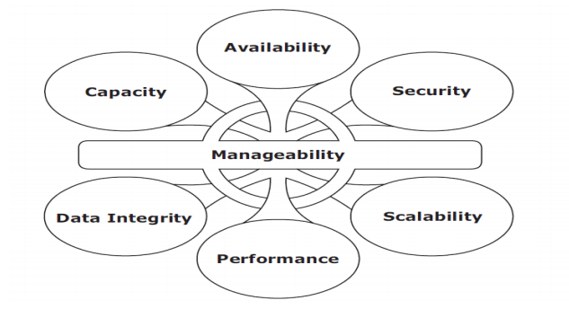
Key requirements for data center elements – Availability, Security, Scalability, Performance, Data Integrity, Capacity around Manageability (PPT Slide 59)
Requirement | Description
Availability | Accessibility should be ensured for a business implementation.
Security | Policies, procedures, and proper integration of the data center core elements that will prevent unauthorized access to information must be established.
Scalability | Additional on-demand services, without interrupting business operations.
Performance | All the core elements of the data center should be able to provide optimal performance and service all processing requests at high speed.
Data integrity | Mechanisms such as error correction codes and parity bits which ensure that data is written to disk exactly as it was received.
Capacity | To increase and decrease core elements capacity on demand.
Manageability | A data center should perform all operations and activities in the most efficient manner. Manageability can be achieved through automation and the reduction of human (manual) intervention in common tasks.

KEY POINT: Mnemonic: A-S-S-P-D-C-M → Availability, Security, Scalability, Performance, Data integrity, Capacity, Manageability.

4. Key Challenges in Managing Information
- Exploding digital universe: The rate of information growth is increasing exponentially. Duplication of data to ensure high availability and repurposing has also contributed to the multifold increase of information growth.
- Increasing dependency on information: The strategic use of information plays an important role in determining the success of a business and provides competitive advantages in the marketplace.
- Changing value of information: Information that is valuable today may become less important tomorrow. The value of information often changes over time. Framing a policy to meet these challenges involves understanding the value of information over its lifecycle.
MINI SUMMARY: Information grows exponentially, businesses depend on it more, and its value keeps changing. Therefore a policy that manages information across its lifecycle (ILM) is required.

5. Information Lifecycle Management (ILM)
DEFINITION: Information lifecycle management (ILM) is a proactive strategy that enables an IT organization to effectively manage the data throughout its lifecycle, based on predefined business policies.

This allows an IT organization to optimize the storage infrastructure for maximum return on investment.

5.1 Characteristics of an ILM Strategy
Characteristic | Description
Business-centric | It should be integrated with key processes, applications, and initiatives of the business to meet both current and future growth in information.
Centrally managed | All the information assets of a business should be under the purview of the ILM strategy.
Policy-based | The implementation of ILM should not be restricted to a few departments. ILM should be implemented as a policy and encompass all business applications, processes, and resources.
Heterogeneous | An ILM strategy should take into account all types of storage platforms and operating systems.
Optimized | Because the value of information varies, an ILM strategy should consider the different storage requirements and allocate storage resources based on the information’s value to the business.

5.2 ILM Implementation
- Classifying data and applications on the basis of business rules and policies to enable differentiated treatment of information.
- Implementing policies by using information management tools, starting from the creation of data and ending with its disposal.
- Managing the environment by using integrated tools to reduce operational complexity.
- Organizing storage resources in tiers to align the resources with data classes, and storing information in the right type of infrastructure based on the information’s current value.

5.3 ILM Benefits
- Improved utilization by using tiered storage platforms and increased visibility of all enterprise information.
- Simplified management by integrating process steps and interfaces with individual tools and by increasing automation.
- A wider range of options for backup and recovery to balance the need for business continuity.
- Maintaining compliance by knowing what data needs to be protected for what length of time.
- Lower Total Cost of Ownership (TCO) by aligning the infrastructure and management costs with information value. As a result, resources are not wasted, and complexity is not introduced by managing low-value data at the expense of high-value data.
SYLLABUS ADDITION: Typical stages of the information lifecycle (textbook): Create → Protect → Access → Migrate → Archive → Reclaim. Information value is highest soon after creation and declines with time; tiered storage moves it from high-performance to low-cost tiers.

MINI SUMMARY: ILM = proactive, policy-based management of data from creation to disposal. Five characteristics: business-centric, centrally managed, policy-based, heterogeneous, optimized. Benefit: better utilization, simpler management, compliance, lower TCO.

6. Components of a Storage System Environment
The three main components in a storage system environment are the Host, Connectivity, and Storage.

6.1 Host
- Users store and retrieve data through applications. The computers on which these applications run are referred to as hosts.
- Hosts can range from simple laptops to complex clusters of servers.
- A host consists of physical components (hardware devices) that communicate with one another using logical components (software and protocols).
- Access to data and the overall performance of the storage system environment depend on both the physical and logical components of a host.

Physical Components of a Host
Component | Details
CPU | Arithmetic Logic Unit (ALU), Control Unit, Register, Level 1 (L1) cache
Storage | Internal memory and disk devices: RAM, ROM, Hard disk (magnetic), CD-ROM or DVD-ROM (optical), Floppy disk (magnetic), Tape drive (magnetic)
I/O devices | User-to-host communications, Host-to-host communications, Host-to-storage device communications

6.2 Connectivity
The discussion here focuses on the connectivity between the host and the storage device. The components of connectivity can be classified as Physical and Logical. The physical components are the hardware elements that connect the host to storage, and the logical components of connectivity are the protocols used for communication between the host and storage.

Physical Components of Connectivity
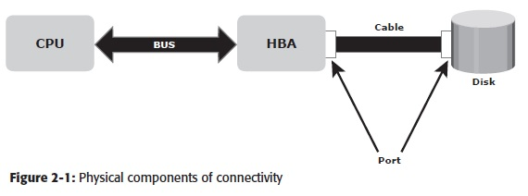
Figure 2-1: CPU ↔ BUS ↔ HBA ↔ Cable (through Ports) ↔ Disk (PPT Slide 8)
- The bus is the collection of paths that facilitates data transmission from one part of a computer to another, such as from the CPU to the memory.
- The port is a specialized outlet that enables connectivity between the host and external devices.
- Cables connect hosts to internal or external devices using copper or fiber optic media.
- Physical components communicate across a bus by sending bits (control, data, and address) of data between devices. These bits are transmitted through the bus either serially or in parallel.

Logical Components of Connectivity
The popular interface protocol used for the local bus to connect to a peripheral device is peripheral component interconnect (PCI). The interface protocols that connect to disk systems are Integrated Device Electronics/Advanced Technology Attachment (IDE/ATA) and Small Computer System Interface (SCSI).
- PCI
- IDE/ATA
- SCSI

6.3 Storage
A storage device uses magnetic or solid state media. Disks, tapes, and diskettes use magnetic media. CD-ROM is an example of a storage device that uses optical media, and removable flash memory card is an example of solid state media.

Tape
- Tapes are a popular storage media used for backup because of their relatively low cost.
- In the past, data centers hosted a large number of tape drives and processed several thousand reels of tape.
Limitations of tape:
- Data is stored on the tape linearly along the length of the tape. Search and retrieval of data is done sequentially, invariably taking several seconds to access the data.
- As a result, random data access is slow and time consuming. This limits tapes as a viable option for applications that require real-time, rapid access to data.
- Data stored on tape cannot be accessed by multiple applications simultaneously, restricting its use to one application at a time.
- On a tape drive, the read/write head touches the tape surface, so the tape degrades or wears out after repeated use.
- The storage and retrieval requirements of data from tape and the overhead associated with managing tape media are significant.
MINI SUMMARY: Storage environment = Host (physical + logical components) + Connectivity (bus, port, cable; PCI, IDE/ATA, SCSI) + Storage (magnetic, optical, solid state). Tape is cheap and good for backup but sequential and slow.

7. Disk Drive Components
A disk drive uses a rapidly moving arm to read and write data across a flat platter coated with magnetic particles. Data is transferred from the magnetic platter through the R/W head to the computer. Several platters are assembled together with the R/W head and controller, most commonly referred to as a hard disk drive (HDD). Data can be recorded and erased on a magnetic disk any number of times.
Key components of a disk drive (Figure 2-2): Platter, Spindle, Read/Write Head, Actuator Arm Assembly, Controller, Physical Disk Structure, Zoned Bit Recording, Logical Block Addressing.

7.1 Platter
- A typical HDD consists of one or more flat circular disks called platters. The data is recorded on these platters in binary codes (0s and 1s).
- The set of rotating platters is sealed in a case, called a Head Disk Assembly (HDA).
- A platter is a rigid, round disk coated with magnetic material on both surfaces (top and bottom).
- The data is encoded by polarizing the magnetic area, or domains, of the disk surface.

7.2 Spindle
- A spindle connects all the platters and is connected to a motor. The motor of the spindle rotates with a constant speed. The disk platter spins at a speed of several thousands of revolutions per minute (rpm).
- Disk drives have spindle speeds of 7,200 rpm, 10,000 rpm, or 15,000 rpm.
- Disks used on current storage systems have a platter diameter of 3.5” (90 mm).
- When the platter spins at 15,000 rpm, the outer edge is moving at around 25 percent of the speed of sound.

7.3 Read/Write Head
- Read/Write (R/W) heads read and write data from or to a platter. Drives have two R/W heads per platter, one for each surface of the platter.
- The R/W head changes the magnetic polarization on the surface of the platter when writing data. While reading data, this head detects magnetic polarization on the surface of the platter.
- During reads and writes, the R/W head senses the magnetic polarization and never touches the surface of the platter.
- When the spindle is rotating, there is a microscopic air gap between the R/W heads and the platters, known as the head flying height.
- This air gap is removed when the spindle stops rotating and the R/W head rests on a special area on the platter near the spindle. This area is called the landing zone. The landing zone is coated with a lubricant to reduce friction between the head and the platter.

7.4 Actuator Arm Assembly
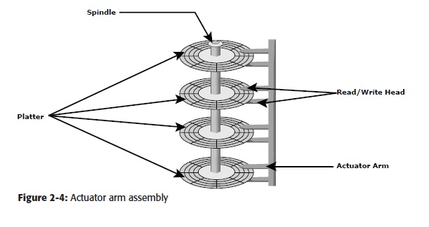
Figure 2-4: Actuator arm assembly – spindle, platters, R/W heads, actuator arm (PPT Slide 18)
- The R/W heads are mounted on the actuator arm assembly, which positions the R/W head at the location on the platter where the data needs to be written or read.
- The R/W heads for all platters on a drive are attached to one actuator arm assembly and move across the platters simultaneously.
- Note that there are two R/W heads per platter, one for each surface.

7.5 Controller
- The controller is a printed circuit board, mounted at the bottom of a disk drive. It consists of a microprocessor, internal memory, circuitry, and firmware.
- The firmware controls power to the spindle motor and the speed of the motor.
- It also manages communication between the drive and the host.
- In addition, it controls the R/W operations by moving the actuator arm and switching between different R/W heads, and performs the optimization of data access.

7.6 Physical Disk Structure
- Data on the disk is recorded on tracks, which are concentric rings on the platter around the spindle.
- The tracks are numbered, starting from zero, from the outer edge of the platter.
- The number of tracks per inch (TPI) on the platter (or the track density) measures how tightly the tracks are packed on a platter.
SYLLABUS ADDITION: Textbook completion: Each track is divided into smaller units called sectors (smallest addressable unit, typically 512 bytes). A cylinder is the set of tracks at the same position on all platters (all surfaces). Tracks are separated by guard spaces; sectors are separated by intersector gaps. Sector holds a header (sector number, location), data field (512 bytes) and error-correction code (ECC).

7.7 Zoned Bit Recording
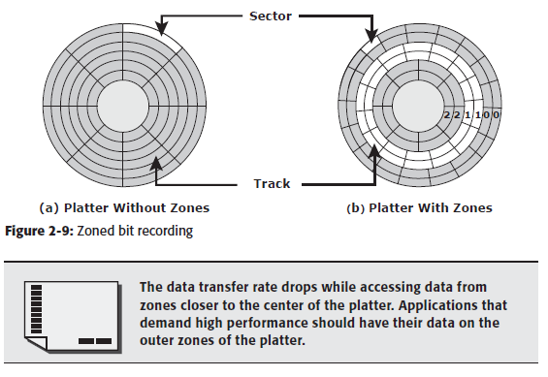
Figure 2-9: (a) Platter without zones, (b) Platter with zones (PPT Slide 24)
- Because the platters are made of concentric tracks, the outer tracks can hold more data than the inner tracks, because the outer tracks are physically longer than the inner tracks.
- On older disk drives, the outer tracks had the same number of sectors as the inner tracks, so data density was low on the outer tracks. This was an inefficient use of available space. Zone bit recording utilizes the disk efficiently.
- This mechanism groups tracks into zones based on their distance from the center of the disk. The zones are numbered, with the outermost zone being zone 0.
KEY POINT: The data transfer rate drops while accessing data from zones closer to the center of the platter. Applications that demand high performance should have their data on the outer zones of the platter.

7.8 Logical Block Addressing (LBA)
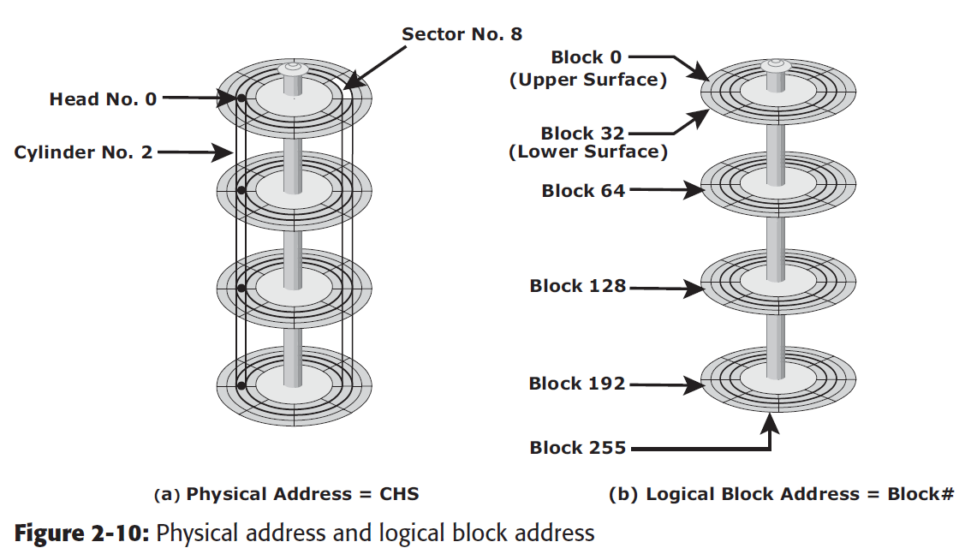
Figure 2-10: (a) Physical address = CHS, (b) Logical block address = Block # (PPT Slide 26)
- Earlier drives used physical addresses consisting of the cylinder, head, and sector (CHS) number to refer to specific locations on the disk, and the host operating system had to be aware of the geometry of each disk being used.
- Logical block addressing (LBA) simplifies addressing by using a linear address to access physical blocks of data.
- The disk controller translates LBA to a CHS address, and the host only needs to know the size of the disk drive in terms of the number of blocks.
- The logical blocks are mapped to physical sectors on a 1:1 basis.
Feature | CHS Addressing | LBA
Address form | Cylinder + Head + Sector | Single linear block number (Block 0, 1, 2 …)
Host knowledge | OS must know disk geometry | Host only needs total number of blocks
Translation | None | Disk controller translates LBA → CHS

MINI SUMMARY: HDD = platters + spindle + R/W heads + actuator arm + controller. Data is on tracks → sectors; ZBR packs more sectors on outer tracks; LBA gives a simple linear address mapped 1:1 to sectors.

8. Disk Drive Performance
A disk drive is an electromechanical device that governs the overall performance of the storage system environment.

8.1 Disk Service Time
DEFINITION: Disk service time is the time taken by a disk to complete an I/O request. Components that contribute to service time on a disk drive are seek time, rotational latency, and data transfer rate.

(a) Seek Time
The seek time (also called access time) describes the time taken to position and settle the arm and the head over the correct track. Therefore, the lower the seek time, the faster the I/O operation.
Type | Meaning
Full Stroke | The time taken by the R/W head to move across the entire width of the disk, from the innermost track to the outermost track.
Average | The average time taken by the R/W head to move from one random track to another, normally listed as the time for one-third of a full stroke.
Track-to-Track | The time taken by the R/W head to move between adjacent tracks.

The average seek time on a modern disk is typically in the range of 3 to 15 milliseconds.

(b) Rotational Latency
- To access data, the actuator arm moves the R/W head over the platter to a particular track while the platter spins to position the requested sector under the R/W head.
- The time taken by the platter to rotate and position the data under the R/W head is called rotational latency.
- This latency depends on the rotation speed of the spindle and is measured in milliseconds. The average rotational latency is one-half of the time taken for a full rotation.
- Similar to the seek time, rotational latency has more impact on the reading/writing of random sectors on the disk than on the same operations on adjacent sectors.
FORMULA: Average Rotational Latency = ½ × Time per Revolution

Average rotational latency is approximately 5.5 ms for a 5,400-rpm drive, and around 2.0 ms for a 15,000-rpm (or 250-rps) drive:
15,000 rpm → RPS = 15,000 / 60 = 250 revolutions per second
Average rotational latency = 0.5 / 250 = 0.002 s = 2 milliseconds

(c) Data Transfer Rate
- The data transfer rate (also called transfer rate) refers to the average amount of data per unit time that the drive can deliver to the HBA.
- Read operation: data first moves from disk platters to R/W heads; then it moves to the drive’s internal buffer. Finally, data moves from the buffer through the interface to the host HBA.
- Write operation: data moves from the HBA to the internal buffer of the disk drive through the drive’s interface. The data then moves from the buffer to the R/W heads. Finally, it moves from the R/W heads to the platters.
The data transfer rates during the R/W operations are measured in terms of internal and external transfer rates.
 | Internal Transfer Rate | External Transfer Rate
Meaning | Speed at which data moves from a platter’s surface to the internal buffer (cache) of the disk. | Rate at which data can move through the interface to the HBA.
Factors | Takes into account factors such as seek time and rotational latency. | Generally the advertised speed of the interface, e.g., 133 MB/s for ATA.
Note | – | The sustained external transfer rate is lower than the interface speed.

MINI SUMMARY: Service time = Seek time + Rotational latency + Transfer time. Seek: 3–15 ms (avg = 1/3 full stroke). Avg rotational latency = ½ rotation (2 ms at 15K rpm). Transfer rate has internal and external components.

9. Fundamental Laws Governing Disk Performance

9.1 Disk I/O Controller Utilization
To understand the laws of disk performance, a disk can be viewed as a black box consisting of two elements:
- Queue: The location where an I/O request waits before it is processed by the I/O controller.
- Disk I/O Controller: Processes I/Os that are waiting in the queue one by one.
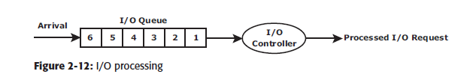
Figure 2-12: I/O processing – Arrival → I/O Queue → I/O Controller → Processed I/O request (PPT Slide 35)
SYLLABUS ADDITION: The laws used in this model (textbook, Utilization Law / Little’s Law): Utilization (U) = Arrival rate (a) × Service time (Rs); Response time (R) = Service time / (1 − Utilization); Little’s Law: N = a × R (average number of requests in the system = arrival rate × response time). Average number of requests in queue = U² / (1 − U).

Relationship between Utilization and Response Time
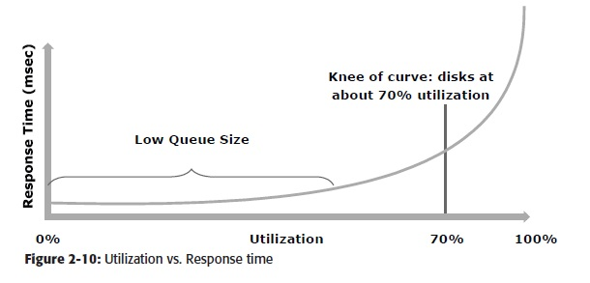
Figure 2-10: Utilization vs. Response time – knee of curve at about 70 % utilization (PPT Slide 36)
- By reducing the service time (the sum of seek time, latency, and internal transfer rate) or utilization by half, the response time can be reduced drastically (almost six times in the textbook example).
- Response time changes are nonlinear as utilization increases.
- When the average queue sizes are low, response time remains low.
- Response time increases slowly with added load on the queue, and increases exponentially when utilization exceeds 70 percent.
KEY POINT: Keep disk utilization below 70 % (the “knee of the curve”) for good response time.

10. Storage Design Based on Application Requirements and Disk Performance
- Determining storage requirements for an application is estimated by the size and number of file systems and database components used by applications.
- The I/O size, I/O characteristics, and the number of I/Os generated by the application at peak workload are other factors that affect disk performance, I/O response time, and design of storage systems.
- The I/O block size depends on the file system and the database on which the application is built.
- The disk service time (TS) for an I/O is a key measure of disk performance; TS, along with disk utilization rate (U), determines the I/O response time for an application.
FORMULA: TS = T + L + X
where T = seek time, L = rotational latency, X = internal transfer time

10.1 Worked Example – Service Time and IOPS
Specifications of the disk:
- Average seek time is 5 ms in a random I/O environment → T = 5 ms.
- Disk rotation speed of 15,000 rpm or 250 rps → rotational latency L = 0.5/250 s (one-half of the time taken for a full rotation).
- 40 MB/s internal data transfer rate → internal transfer time X = block size / transfer rate, e.g., for a 32 KB block, X = 32 KB / 40 MB.
TS = 5 ms + (0.5/250) + 32 KB/40 MB
TS = 5 ms + 2 ms + 0.8 ms = 7.8 ms

Maximum IOPS = 1 / TS = 1 / (7.8 × 10^-3) = 128 IOPS

10.2 Response Time and Utilization
FORMULA: R = TS / (1 – U)

- The application response time, R, increases with an increase in disk controller utilization.
- Example: response time for an I/O with block size 32 KB at 96 % utilization:
R = TS / (1 – U) = 7.8 / (1 – 0.96) = 195 ms

- If the application demands a faster response time, the utilization for the disks should be maintained below 70 percent. For the same 32-KB block, at 70 % utilization, response time reduces drastically to 26 ms.
- However, at lower disk utilization, the number of IOPS a disk can perform is also reduced. For a 32-KB block, a disk can perform 128 IOPS at almost 100 % utilization, whereas at 70 % utilization it can perform 89 IOPS (128 × 0.7).
- Therefore, the storage requirement for an application is determined in terms of both capacity and IOPS.
- If an application needs 200 GB of disk space, this can be provided by a single disk. But if the application IOPS requirement is high, performance degrades, because a single disk might not provide the required response time.

10.3 Number of Disks Required
FORMULA: DR = Max (DC, DI)
DC = disks required to meet the capacity; DI = disks required to meet the application IOPS requirement

Example
Capacity requirement = 1.46 TB; peak workload = 9,000 IOPS; vendor specifies a 146-GB, 15,000-rpm drive does a maximum of 180 IOPS.
Step | Calculation | Result
Disks for capacity (DC) | 1.46 TB / 146 GB | 10 disks
Disks for IOPS (DI) | 9,000 / 180 | 50 disks
If response-time sensitive: IOPS per disk at 70 % utilization | 180 × 0.7 | 126 IOPS
Disks for IOPS at 70 % utilization | 9,000 / 126 | 72 disks
DR = Max (10, 72) |  | 72 disks

- From a capacity perspective, 10 disks are sufficient; however, the number of disks required to meet application performance is 72.
- To optimize disk requirements from a performance perspective, various solutions are deployed in a real-time environment: disk native command queuing, use of flash drives, RAID, and the use of cache memory.
MINI SUMMARY: Storage must be sized for both capacity and IOPS: DR = Max(DC, DI). TS = T + L + X; IOPS = 1/TS; R = TS/(1−U); keep U ≤ 70 %.

11. Introduction to Flash Drives
- Traditionally, high I/O requirements were met by simply using more disks. Availability of enterprise class flash drives (EFD) has changed the scenario.
- Flash drives, also referred to as solid state drives (SSDs), are new generation drives that deliver ultra-high performance required by performance-sensitive applications.
- Flash drives use semiconductor-based solid state memory (flash memory) to store and retrieve data.
- Unlike conventional mechanical disk drives, flash drives contain no moving parts; therefore, they do not have seek and rotational latencies.
- Flash drives deliver a high number of IOPS with very low response times. Being semiconductor based, they consume less power compared to mechanical drives.
- Especially suited for applications with small block size and random-read workloads that require consistently low (less than 1 millisecond) response times.
- Applications that need to process massive amounts of information quickly, such as currency exchange, electronic trading systems, and real-time data feed processing, benefit from flash drives.
Parameter | EFD vs. Mechanical Disk
Throughput | Up to 30 times higher
Response time | Up to one-tenth (<1 ms compared with 6–10 ms)
Energy per TB | Up to 38 % less
Power per I/O | Approximately 98 % less

11.1 Components and Architecture of Flash Drives
- Flash drives use similar physical form factor and connectors as mechanical disk drives to maintain compatibility. This enables easy replacement of a mechanical disk drive with a flash drive in a storage array enclosure.
Key components:
- Controller – manages the functioning of the drive.
- I/O interface – provides power and data access.
- Mass storage – an array of nonvolatile NAND (negated AND) memory chips used for storing data.
- Cache – serves as a temporary space or buffer for data transaction and operations.
- A flash drive uses multiple parallel I/O channels (from its drive controller to the flash memory chips) for data access. Generally, the larger the number of flash memory chips and channels, the higher the drive’s internal bandwidth, and ultimately the higher the drive’s performance. Flash drives typically have eight to 24 channels.

11.2 Flash Memory Organization
- Memory chips in flash drives are logically organized in blocks and pages.
- A page is the smallest object that can be read or written on a flash drive. Pages are grouped together into blocks. (These blocks should not be confused with the 512-byte blocks in mechanical disk drive sectors.)
- A block may have 32, 64, or 128 pages. Pages do not have a standard size; typical page sizes are 4 KB, 8 KB, and 16 KB.
- Because flash drives emulate mechanical drives that use LBAs, a page spans across a consecutive series of data blocks. For example, a 4-KB page would span across eight 512-byte data blocks with consecutive addresses.
- A read operation can happen at the page level, whereas a write or an erase operation happens only at the block level.

11.3 Features of Enterprise Flash Drives
- NAND flash memory technology: NAND memory is well suited for accessing random data. A NAND device uses bad block tracking and error correcting code (ECC) to maintain data integrity and provide the fastest write speeds.
- Single-Level Cell (SLC)-based flash: NAND technology is available in two cell designs. A multi-level cell (MLC) stores more than one bit per cell by virtue of its capability to register multiple states, versus a single-level cell that can store only 1 bit. SLC is the preferred technology for enterprise data applications due to its performance and longevity.
SLC vs MLC | SLC | MLC
Bits per cell | 1 | More than 1
Read speed | Typically twice that of MLC | Lower
Write speed | Up to four times higher | Lower
Write/erase cycles | Typically 10 times higher | Lower
Reliability | Higher (only 1 bit per cell → less likelihood of error) | Lower

- Wear (write) leveling technique: An important element of maximizing a flash drive’s useful life is ensuring that the individual memory cells experience uniform use. Data that is frequently updated is written to different locations to avoid rewriting the same cells. In EFDs, with any new write operation, the youngest block is used.
MINI SUMMARY: Flash = no moving parts, no seek/rotational latency, <1 ms response, high IOPS, low power. Components: controller, I/O interface, NAND mass storage, cache. Page = read unit, block = write/erase unit. SLC preferred for enterprise; wear leveling extends life.

12. Logical Components of the Host
The logical components of a host consist of the software applications and protocols that enable data communication with the user as well as the physical components. They are: Operating system, Device drivers, Volume manager, File system, Application.

12.1 Operating System
- An operating system controls all aspects of the computing environment. It works between the application and physical components of the computer system.
- One of the services it provides to the application is data access.

12.2 Device Driver
- A device driver is special software that permits the operating system to interact with a specific device, such as a printer, a mouse, or a hard drive.
- It enables the operating system to recognize the device and to use a standard interface (provided as an API) to access and control devices.
- Device drivers are hardware dependent and operating system specific.

12.3 Volume Manager
- Disk partitioning was introduced to improve the flexibility and utilization of HDDs. In partitioning, an HDD is divided into logical containers called logical volumes (LVs).
- For example, a large physical drive can be partitioned into multiple LVs to maintain data according to the file system’s and applications’ requirements.
- The partitions are created from groups of contiguous cylinders when the hard disk is initially set up on the host.
- The host’s file system accesses the partitions without any knowledge of partitioning and the physical structure of the disk.
- Concatenation is the process of grouping several smaller physical drives and presenting them to the host as one logical drive.
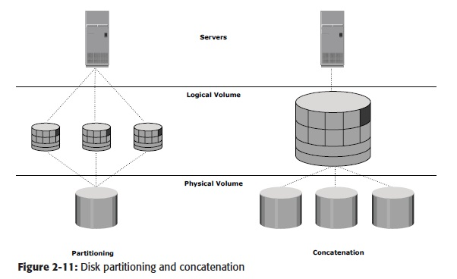
Figure 2-11: Disk partitioning and concatenation (Servers → Logical Volume → Physical Volume) (PPT Slide 53)
 | Partitioning | Concatenation
Operation | One large physical drive → multiple logical volumes | Several small physical drives → one logical volume
Purpose | Flexibility and better utilization of HDD | Present smaller drives as a single large drive

SYLLABUS ADDITION: The Logical Volume Manager (LVM) is software that runs on the host and manages the logical and physical storage. It has three components: Physical Volumes (PV), Volume Groups (VG) and Logical Volumes (LV). LVM can also provide mirroring, striping and dynamic resizing.

12.4 File System
- A file is a collection of related records or data stored as a unit with a name.
- A file system is a hierarchical structure of files. File systems enable easy access to data files residing within a disk drive, a disk partition, or a logical volume.
- A file system needs host-based logical structures and software routines that control access to files. It provides users with the functionality to create, modify, delete, and access files.
- Access to the files on the disks is controlled by the permissions given to the file by the owner, which are also maintained by the file system.
File System | Operating System
FAT 32 (File Allocation Table) | Microsoft Windows
NT File System (NTFS) | Microsoft Windows
UNIX File System (UFS) | UNIX
Extended File System (EXT2/3) | Linux

File System Block
- A file system block is the smallest “container” of physical disk space allocated for data. Each file system block is a contiguous area on the physical disk.
- The block size of a file system is fixed at the time of its creation. File system size depends on block size and the total number of blocks of data stored.
- A file can span multiple file system blocks because most files are larger than the predefined block size of the file system.
- File system blocks cease to be contiguous (i.e., become fragmented) when new blocks are added or deleted. Over time, as files grow larger, the file system becomes increasingly fragmented.

Mapping User Files to the Disk Storage Subsystem (with LVM)
- Files are created and managed by users and applications.
- These files reside in the file systems.
- The file systems are then mapped to units of data, or file system blocks.
- The file system blocks are mapped to logical extents.
- These in turn are mapped to disk physical extents either by the operating system or by the LVM.
- These physical extents are mapped to the disk storage subsystem.
KEY POINT: Mapping chain: Files → File system → FS blocks → Logical extents → Physical extents → Disk storage subsystem.

12.5 Application
- An application is a computer program that provides the logic for computing operations. It sends requests to the underlying operating system to perform read/write (R/W) operations on storage devices.
- Applications can be layered on the database, which in turn uses the OS services to perform R/W operations (e.g., database applications access data via block-level or file-level access).
MINI SUMMARY: Logical components: OS → device drivers → volume manager (partitioning/concatenation, LVs) → file system (files, permissions, blocks) → application.

13. Concept in Practice: VMware ESXi
- VMware is the leading provider for a server virtualization solution. VMware ESXi provides a platform called hypervisor.
- The hypervisor abstracts CPU, memory, and storage resources to run multiple virtual machines concurrently on the same physical server.
- VMware ESXi is a hypervisor that installs on x86 hardware to enable server virtualization. It enables creating multiple virtual machines (VMs) that can run simultaneously on the same physical machine.
- A VM is a discrete set of files that can be moved, copied, and used as a template. All the files that make up a VM are typically stored in a single directory on a cluster file system called Virtual Machine File System (VMFS).
- The physical machine that houses ESXi is called the ESXi host. ESXi hosts provide physical resources used to run virtual machines.

Key Components of ESXi
Component | Function
VMkernel | Provides functionality similar to other operating systems, such as process creation, file system management, and process scheduling. Designed specifically to support running multiple VMs and provide core functionality such as resource scheduling, I/O stacks, and so on.
Virtual Machine Monitor (VMM) | Responsible for executing commands on the CPUs and performing Binary Translation (BT). Performs hardware abstraction to appear as a physical machine with its own CPU, memory, and I/O devices. Each VM is assigned a VMM that has a share of the CPU, memory, and I/O devices to successfully run the VM.

14. Storage Provisioning (including Virtual Provisioning)
SYLLABUS ADDITION: Storage provisioning is part of the syllabus but is not covered in the uploaded PPT. Added in standard textbook form for completeness.

14.1 Storage Provisioning
DEFINITION: Storage provisioning is the process of assigning storage resources (capacity) to hosts/applications based on their capacity, availability and performance requirements.

- Storage is carved out of the storage array as LUNs (Logical Unit Numbers) and presented to the host through the connectivity layer.
- Provisioning may be done by the storage administrator manually or through automated tools.

14.2 Traditional (Thick) Provisioning
- The full requested capacity is allocated up front to the host (a LUN of 500 GB reserves 500 GB of physical space immediately).
- Administrators usually allocate more than the immediate need to avoid frequent expansion and application downtime.
Drawbacks:
- Low capacity utilization – allocated but unused space cannot be used by other hosts.
- Wasted power, cooling and floor space for idle capacity; higher cost.
- Growing a LUN later may require downtime and complex migration.

14.3 Virtual (Thin) Provisioning
DEFINITION: Virtual provisioning (thin provisioning) presents a host with more capacity than is physically allocated. Physical storage is allocated to the host only when it is needed (on demand) from a shared pool.

Key terms:
- Thin LUN: a logical device presented to the host with a large *virtual* size, but with little or no physical space initially allocated.
- Shared (storage) pool: a pool of physical storage (made from physical drives / RAID groups) from which thin LUNs draw space.
- Over-subscription: the total capacity presented to hosts exceeds the physical capacity in the pool.
- Extent allocation: space is allocated from the pool to thin LUNs in small chunks (extents) as the host writes data.

14.4 Comparison
Parameter | Traditional (Thick) | Virtual (Thin)
Allocation | Full capacity allocated up front | Allocated on demand from a shared pool
Capacity utilization | Low (unused space is stranded) | High (pool is shared)
Cost / power / cooling | Higher | Lower
Expansion | May need downtime / migration | Non-disruptive; add drives to pool
Risk | Wasted capacity | Pool exhaustion if over-subscribed and not monitored
Management | Per-LUN capacity planning | Pool-level monitoring and thresholds

14.5 Advantages of Virtual Provisioning
- Improved storage utilization; reduces upfront cost (buy capacity as needed).
- Simplified capacity planning and administration; non-disruptive growth.
- Reduced power, cooling and floor-space requirements.
- Allows performance to be spread over many drives of the pool (wide striping).

14.6 Related Concepts
- LUN expansion / contraction: growing or shrinking a LUN to match application needs.
- LUN masking and zoning: controlling which hosts can see which LUNs (security in SAN).
- Storage tiering: placing data on flash / FC / SATA tiers according to its value (links with ILM).
KEY POINT: Thick = “reserve everything now”; Thin = “allocate only when data is written”. Thin gives better utilization but needs pool monitoring to avoid running out of physical space.

MINI SUMMARY: Provisioning = assigning storage (LUNs) to hosts. Traditional provisioning wastes space; virtual (thin) provisioning allocates on demand from a shared pool, boosting utilization and cutting cost.

15. Quick Revision

15.1 Formula Sheet
Quantity | Formula | Example / Note
Average rotational latency | ½ × time per revolution = 0.5 / RPS | 15,000 rpm → 0.5/250 = 2 ms
Revolutions per second | RPM / 60 | 15,000 / 60 = 250 rps
Total disk service time | TS = T + L + X | 5 + 2 + 0.8 = 7.8 ms
Internal transfer time | X = block size / internal transfer rate | 32 KB / 40 MB/s = 0.8 ms
Max IOPS | 1 / TS | 1 / 7.8 ms ≈ 128 IOPS
Response time | R = TS / (1 − U) | U = 96 % → 195 ms; U = 70 % → 26 ms
IOPS at 70 % utilization | IOPS × 0.7 | 128 × 0.7 ≈ 89
Disks required | DR = Max (DC, DI) | Max(10, 72) = 72
DC | Capacity required / capacity per disk | 1.46 TB / 146 GB = 10
DI | Required IOPS / IOPS per disk | 9,000 / 126 = 72

15.2 Important Numbers to Remember
- Spindle speeds: 7,200 / 10,000 / 15,000 rpm; platter diameter 3.5”.
- Average seek time: 3–15 ms; average seek = 1/3 full stroke.
- Utilization knee: 70 %.
- Flash: <1 ms vs 6–10 ms; 30× throughput; 8–24 channels; pages 4/8/16 KB; 32/64/128 pages per block.
- SLC: 2× read, 4× write, 10× write/erase cycles vs MLC.

15.3 Likely Exam Questions
- Define data and information. Explain structured vs unstructured data and Big Data.
- Explain the evolution of storage technology and architecture.
- Explain the core elements and key requirements of a data center.
- What are the key challenges in managing information?
- What is ILM? Explain its characteristics, implementation and benefits.
- Explain the components of a storage system environment (host, connectivity, storage).
- Explain the components of a disk drive with a neat diagram.
- Explain zoned bit recording and logical block addressing.
- Explain disk service time: seek time, rotational latency and data transfer rate.
- Explain the relationship between utilization and response time. Why keep utilization below 70 %?
- Calculate IOPS and the number of disks required for given capacity and IOPS (numerical).
- Explain the architecture and features of enterprise flash drives.
- Explain the logical components of a host (OS, device driver, volume manager, file system, application).
- Explain partitioning and concatenation. How are files mapped to disk with LVM?
- Compare traditional and virtual provisioning.

